Mirto 2023 Build Information

This document describes the Pi Pico variant of the Mirto robot.

The robot can be built with or without bump, distance or IR line sensors.

Document Version 0.6 (draft)

Last updated Aug 30 2023 by Michael Margolis

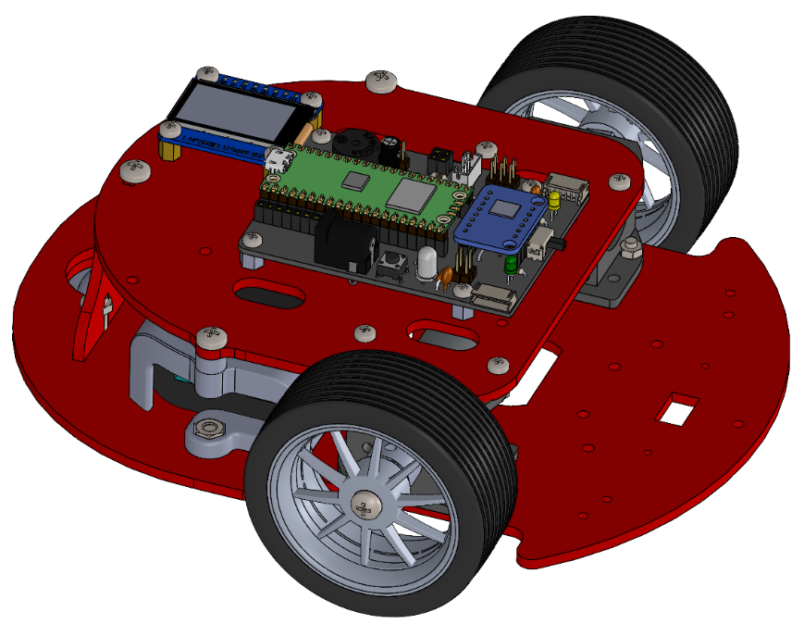

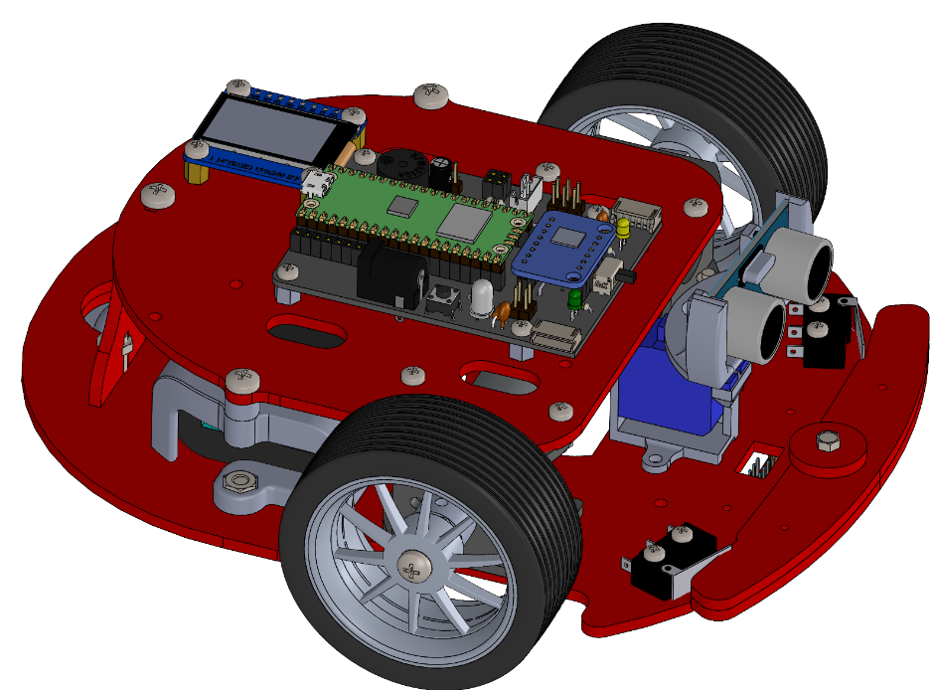Mirto Variants

Figure 1: Basic chassis

Figure 2: Chassis with bump , distance, and IR line sensors

The Mirto robot can be configured with various sensors to detect the environment and can be controlled using a variety of computer boards. These configurations can be changed at any time by adding or removing components but the initial build is easiest if the desired configuration is built in the sequence shown in this document.

Build sequence tips:

1. The build starts with the bottom plate. Motors are attached and the desired sensors are added. You can skip over sections describing sensor that are not required for your build.
2. The electronics boards are attached to the top plate.
3. The electrical connections between the bottom and top plates are easier if done before bolting the top and bottom together.
4. Some of the mounting hardware used for attaching the top and bottom plates differs depending on the battery being used. See the relevant section covering the battery type used in your build.

Sensor options:

* Bump sensors
* IR line sensors
* Ultrasonic distance sensor
  + Mounted on servo (pico version only)
  + Fixed
* Lidar (not covered in this document)

Microcontroller options:

* Arduino WiFI R2 with Mirto shield
* Mirto PCB with Pico WiFi
* Mirto PCB with Pico (not WiFi) and Raspberry Pi)
* Mirto Teensy PCB and Raspberry Pi

Power options:

* Generic USB power bank
* USB bank with custom mount (Currently Anker PowerCore 5k and Anker PoweCore 10k)

Robot Components (see Electronic Assembly Section for wiring and electrical parts not shown).

Supplier part numbers for hardware and electronic components can be found at: https://github.com/michaelmargolis/Mirto2023/tree/main/docs/Mirto_BOM.xlsx

Note orientation of top and bottom plates, left side indicated by letter L

**Figures are not to scale**

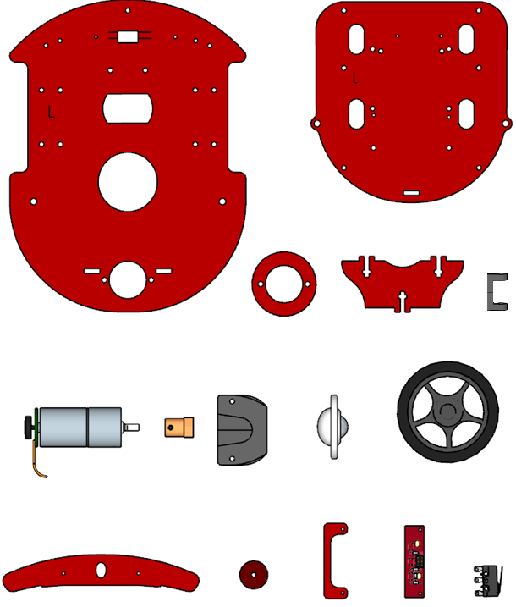

Bumper

(2 pieces if 3mm)

Optional Components

Bumper

Cap

IR Sensor Board

IR Sensors

Spacer x2

Motor Mount x2

Switch X2

Caster

Wheel x2

Offset Spacer

Upper Plate

Bottom Plate

Caster Spacer

Rear bracket

Motor x2

Hub x2

**Hardware for core robot:**

|  |  |  |
| --- | --- | --- |
| Quantity | Description |  |
| 21 | M3 X 12 pan or button head machine screw |  |
| 21 | M3 nut |  |
| 4 | M4 X 8 pan head machine screw |  |

**Hardware for motor mounts:** (Already attached if motor mounts are pre build)

|  |  |  |
| --- | --- | --- |
| Quantity | Description |  |
| 4 | M3 x 5 socket button head machine screw |  |
| 2 | M3 Grub screw |  |
| 2 | M3 nut |  |

**Additional hardware for robot with bump sensors**

|  |  |  |
| --- | --- | --- |
| Quantity | Description |  |
| 1 | M3 X 20 socket button screw |  |
| 1 | M3 locknut |  |
| 1 | Nylon dome nut |  |
| 4 | M2.5 x 12 pan head machine screw |  |
| 4 | M2.5 nut |  |

**Additional Hardware for robots with IR Sensors**

|  |  |  |
| --- | --- | --- |
| Quantity | Description |  |
| 2 | M2 X 12 pan head machine screw |  |
| 2 | M2 nut |  |

**Additional Hardware for robots with Waveshare 1.14 inch IPS-TFT-LCD Display (SKU 18231)**

|  |  |  |
| --- | --- | --- |
| Quantity | Description |  |
| 4 | M3x5 machine screw (or button head) |  |

**Hardware for mounting controller boards:**

Arduino Robot controller mounting hardware (For Arduino Uno Wifi and PCB)

|  |  |  |
| --- | --- | --- |
| Quantity | Description |  |
| 4 | M3 x 8 pan head machine screw |  |
| 4 | M3 nut |  |

CS Robot mounting hardware (for Raspberry Pi and Mirto PCB)

|  |  |  |
| --- | --- | --- |
| Quantity | Description |  |
| 8 | M2.5 x 12 pan head machine screw |  |
| 4 | M2.5 x 4 threaded standoff for Pi |  |
| 4 | M2.5 x 16 threaded standoff for Mirto PCB |  |

Useful tools:

Screwdrivers /hex keys for machine screws and grub screws

M4 tap for 3D printed hubs and standoffs ( if printed tolerance does not allow self threading)

**Build notes:**

* **Read through all steps before beginning assembly**
* Double check hardware before each assembly step and make sure that the length of the screw matches the instructions.
* Look at the prototype if you are not sure how things go together
* Don’t overtighten the screws
* Machine screws are pan head where not specified.
* If using thread lock, apply only after initial assembly

**Motor Assembly**

You can skip the steps on this page

if the motor assemblies are pre-built.

Figure 3: Completed motor assembly

If not already fitted, insert M3 nut into slot on hub and hold in place with grub screw

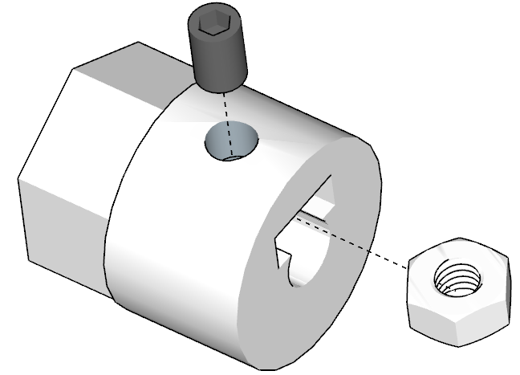

Figure 4: Hub Detail

Attach motors to mount using M3x5 button head screws. Don’t overtighten these screws.

Note left and right motor positions are mirror images, see figure 6.

**Caution – you must use the M3x5 hardware specified, longer screws will damage the gearbox!**

Hardware: 2 off M3 x 5 socket button screws for each motor

2 off M3 grub screws and M3 nuts for hubs

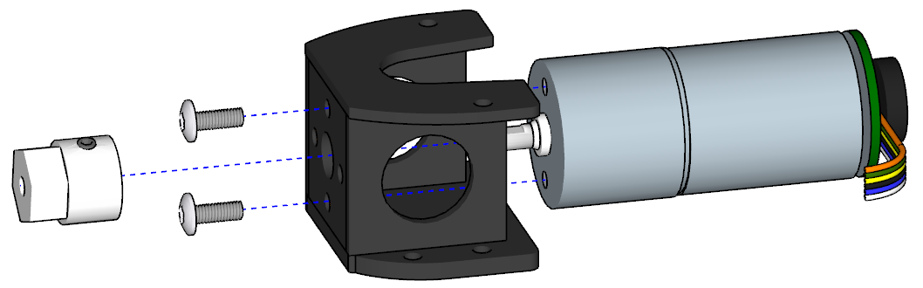

Mount motors so wires face towards the rear when mounted on the bottom plate, see Fig 4.

Figure 5: Motor Mount

Attach hub. There should be a slight gap to avoid touching motor screws

The motor assemblies are attached to the bottom plate with the motor wires facing to rear of the robot. Important: Orient base plate so letter L is on the left side of robot as shown in the figure

Hardware:

8 off M3 x 12 pan head machine screws and nuts

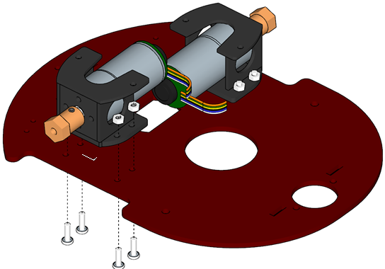

Important: Double check that motors are mounted so both motor wires extend to rear of robot

Figure 6: Mounting motors

Figure 6: Mounting motors

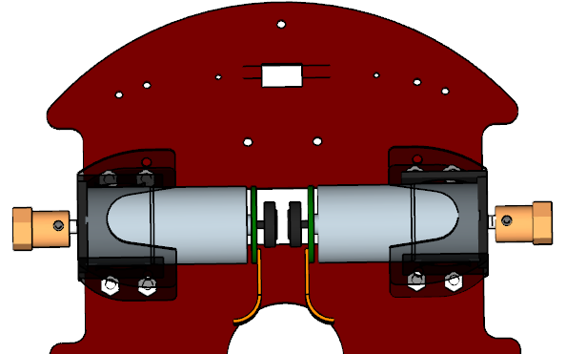

M3 X 12 machine screws

Attach rear bracket and caster.

Hardware:

M3 X 12 machine screws and nuts

Figure 7: Component Location on bottom frame

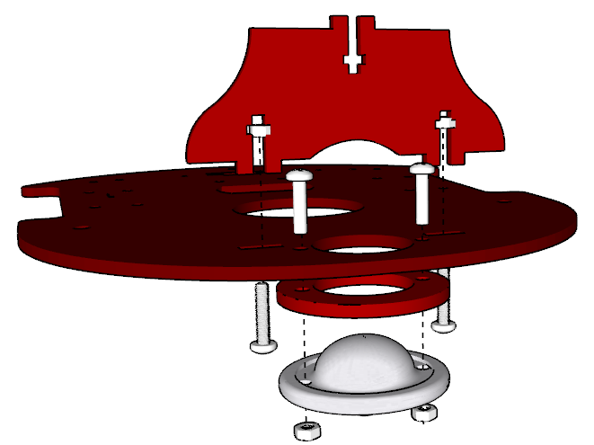

Figure 8: Bottom frame detail - Note the orientation of the caster and spacer (rolling ball faces down)

Only do the steps on this page if building the robot with bump switches or IR Sensors.

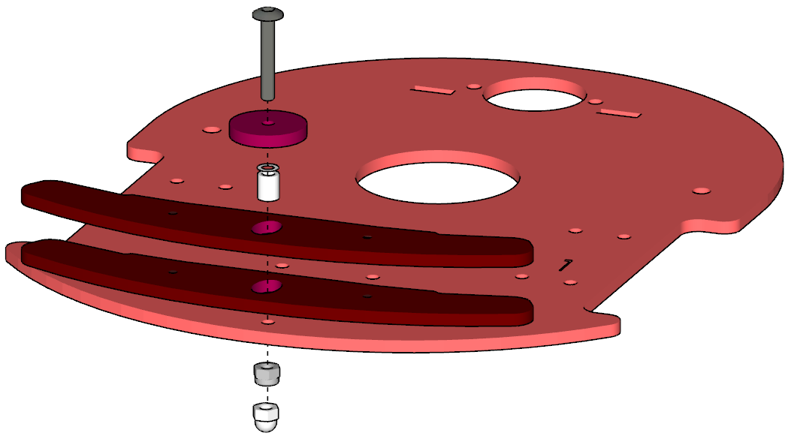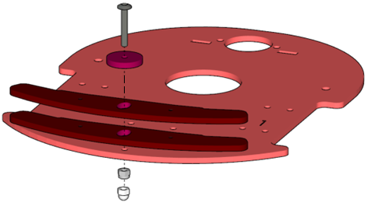Attach two bumpers to the lower plate using a 20mm M3 hex machine screw and nyloc nut. The nyloc nut is metal with a nylon insert that resists turning; you will need to hold this nut with pliers when tightening the screw with a hex key until there is just enough play to allow free movement of the bumpers without lifting off the bottom plate. The plastic dome nut is then screwed onto the bottom to act as a skid to prevent the robot tipping forward and damaging the IR sensors.

Figure 9: Location of Bumper mounting hardware

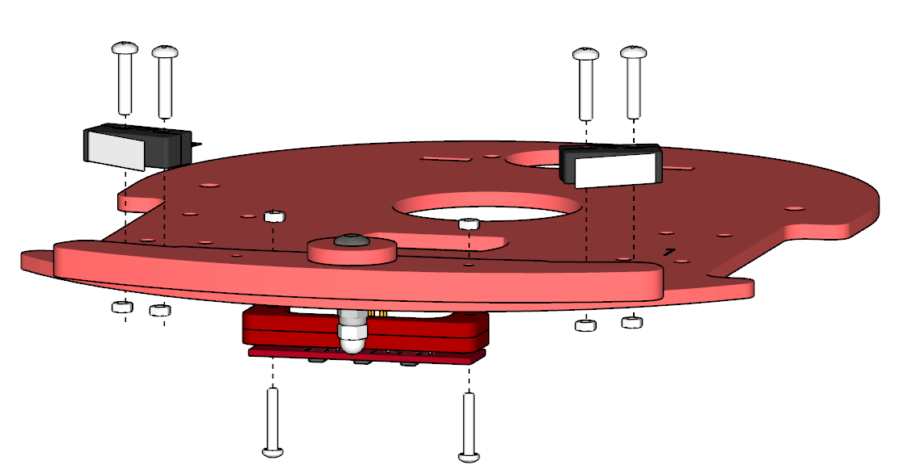

Figure 10: Mounting bump switches and IR sensors

Note the orientation of the switch levers (the hinges on both switches are towards the outside of the plate)

Bump Hardware:

1 off M3 x 20 socket button screw

1 off M3 lock nut

IR sensor Hardware:

4 off M2x12 pan head screws

4 off M2 nuts

1 off M3 plastic dome nut

4 off M2.5 x 12 pan head screws

4 off M2.5 nuts

**Top plate electronics- Mirto 2023 Pico W board**

Controller board mounted using M2.5 X 12 bolts and nuts

**

Figure 11: controller attaches to top plate using 5mm high M2.5 spacers

Figure 13: LCD display detail

Figure 12: LCD display attaches using M3x5 machine screws

Note display orientation, connector faces inwards.

Yellow arrows show mounting hole location.

Attach display using M3 X5 bolts and nuts

**Battery options:**

**Anker 5k**

Attach the right side to the base using M5x8

Machine screw from the underside. The top

Is attached using an M4x16 machine screw.

The other side is attached using an M4x40 machine

Screw and nut.

Figure 14: Anker 5k battery clips

**Anker 10k**

Attach using M4x40 machine screws and nuts.

Figure 15: Anker 10 battery clips

**Generic USB power bank**

Locate the battery on the bottom plate ensuring

the charging and output connectors are accessible. Use an offset standoff on the side

near the battery connectors to allow clearance

for the power and charging cables. The other side

uses a 30mm long M4 standoff.

Figure 16: Generic battery with standoffs

**Fitting the top and bottom together**

**With the top plate located over the bottom, pass the motor and sensor cables through the slots – see the wiring notes on the next page for details. Attach the top using five M3x12 machine screws and nuts.**Wiring Notes**

Figure 18: Battery mounting detail

M4 x 40 machine screw nut

M4 nut

M4x16 machine screw

M4x8

machine screw

M3x12 machine screws

Figure 17: Attaching top to bottom

M3 nut

Note M4 spacers on left and right battery clips

Wiring is easiest if completed before the top is mounted to the base.

With the PCB and LCD mounted to the top plate, connect the these together as follows:

* Connect the cable plug onto the 8 pin LCD connector on the PCB.
* Thread the other end of the cable down through the top plate hole nearest the connector and up on the hole nearest the LCD.
* Run the wire under the corner of the PCB and plug the cable into the LCD.

With the top plate loosely positioned over the base:

* Thread the motor wires through holes near each motor
* Thread the four pin bump switch connector through the right hand side motor hole
* Thread the six pin IR connector through the left side motor hole
* If using a servo, thread the servo cable through the hole nearest the LCD

Attach the top and bottom plates as shown in figure 17

Plug in the connectors as shown in the Mirto wiring Figure 19

Plug the battery connector to the round DC connector.

If using the distance sensor, connect the four pin cable as follows:

* The white plug connects to the PCB socket marked Stemma I2C1
* The black end connected to the distance sensor, note the black wire must connected to the side marked GND.

**Mirto 2023 wiring**

Figure 19: Electrical connections

Wire colors may vary on the LCD cable. Ensure that the order of the colors on the LCD connecter is the same as the PCB connector.

Servo ground wire this side

Test pushbutton

Motor connector

Motor connector

Bump

cable

Battery connector

Micro USB

Same

Color

wire

LCD

connector

Distance sensor

IR Cable

LCD cable through this hole

ground wire here

**Attach Wheels**

Push the wheels onto the hubs and attach with M4X8 machine screws

Hardware:

2 M4 x 8 machine screws

Figure 20: Attach wheels

**Testing the robot:**

If the Mirto Arduino sketch has not been loaded, connect the micro USB connector (see figure 19) to a computer with the ASIP Arduino environment and load this sketch:

[mirtoWifiWebsocket at GitHub michaelmargolis/ASIP-V1.2](https://github.com/michaelmargolis/ASIP-V1.2/tree/main/asipRobot/examples/mirtoWifiWebsocket)

With the sketch loaded, power the robot while holding down the test pushbutton (see figure 19). When the LCD displays “Test Mode”, release the button. If all is well, you should hear some tones while the LCD display changes colors. The display will then show readings from the distance sensor and the IR line sensors if these are fitted.

After completing testing, press the pushbutton to restart the robot.

**Appendix A – Alternative top plate electronics**

**CS Mirto using Teensy 3.2 or Pico board and Raspberry Pi**

Attach four M2.5X4 spacers using M2.5X12 machine screws. Note the location of the holes as shown in figure

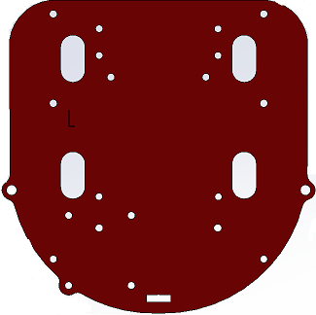

Figure 8A: Mounting standoffs for the Raspberry Pi

Figure 8B: Location of Raspberry Pi mounting holes

The Raspberry pi is inserted onto the screws and held in place using four M2.5X16 threaded standoffs. The Mirto2020 PCB is plugged into the Pi and secured using four M2.5X12 machine screws.

Figure 8C: Raspberry Pi positioned on standoffs

Figure 8D: Mirto circuit board on top of Pi

Hardware:

4 M2.5 x 4 standoffs

4 M2.5 x 16 standoffs

8 M2.5 x 12 machine screws

Boards that do not have build-in LCD display are attached to the top plate using the hole positions shown below:

Teensy .96 OLED LCD mounting position. Teensy 1.3 OLED LCD mounting position.

The Teensy PCBs has an I2C Display.

Ensure the wires are connected as per the pin labels on the display and the silkscreen markings on the boards I2C connector.

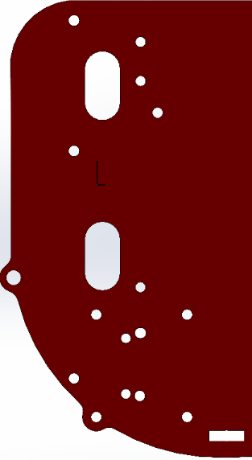

Assembling the Arduino version:

Attach the Arduino mount using four M3x8 machine screws and nuts. The mount is supplied with Arduino Uno WiFi rev 2 or can be ordered from Arduino supplier as part number X000019.

The Arduino board and Mirto PCB can be press fitted to the mount after assembling the robot.

Hardware:

4 M3 x 8 machine screws

4 M3 nuts

Figure 9A: Location of mounting holes for Arduino mount

Figure 9B: Attaching Arduino mount

Figure 9C: Arduino and motor shield located on mount

**Appendix B - Electronic Assembly and Wiring Information**

The IR Sensor Connector Board is made by inserting three IR sensors from the underside of the board. Three 47K resistors and one 47 ohm resistor are placed on the upper side of the board. Solder two 0.1 uF ceramic capacitors and the 2x3 connector as shown below.

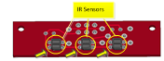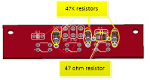

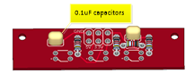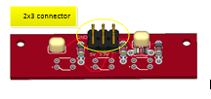Yellow arrows points to orientation notches

Figure 12: IR Sensor Connector Board

The IR sensors are connected to the main circuit board using approximately 14cm of 6 conductor IDC cable.

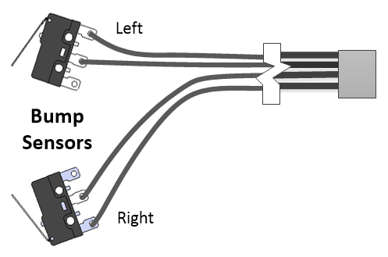The bump switch assembly is made by soldering approximately 16 cm of four conductor ribbon cable to the switches as shown. The other end is crimped into a 2x2 IDC ribbon connector.

Figure13: Bump Switch Wiring

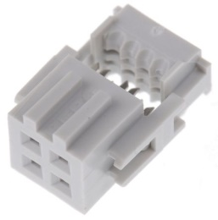

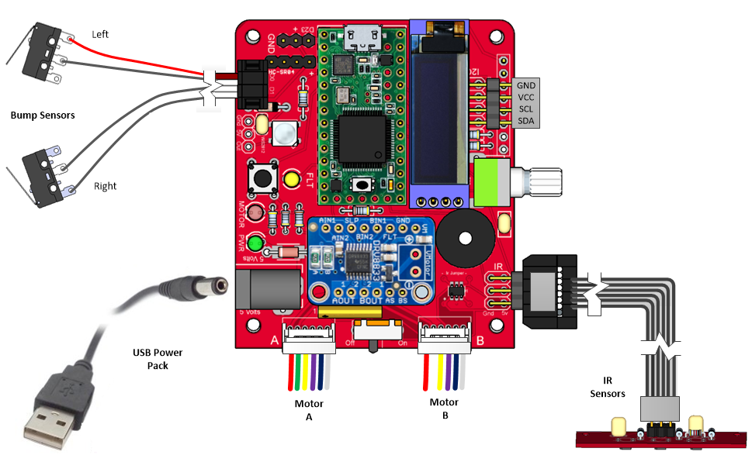

Figure 14: Wiring the Mirto 2020 board for Raspberry Pi

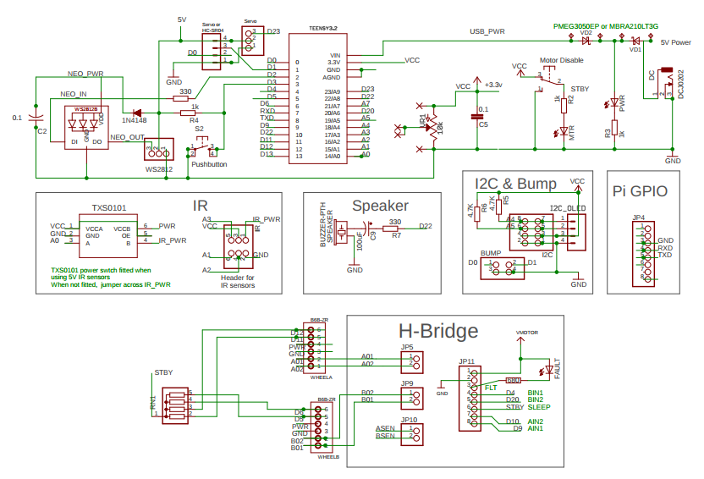

Figure 15: Schematic Diagram

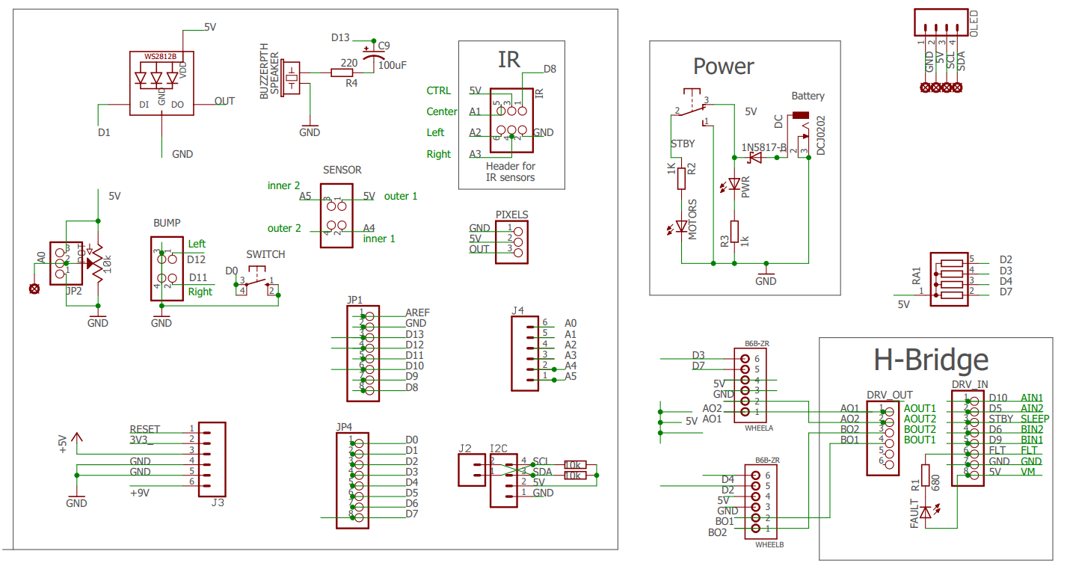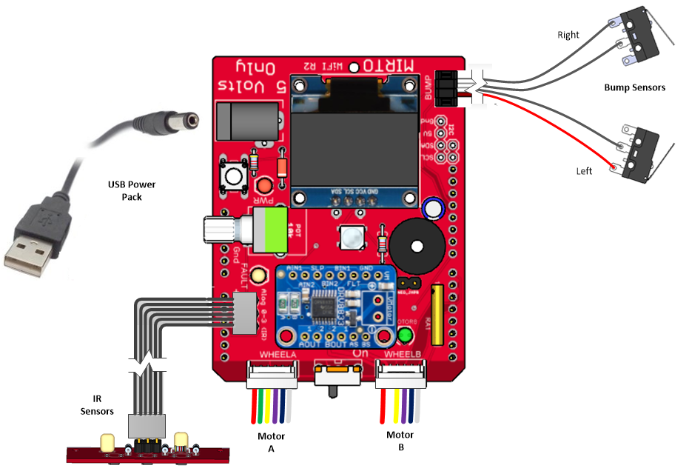

Figure 17: Schematic Diagram

Figure 16: Wiring the Mirto Wifi R2 board

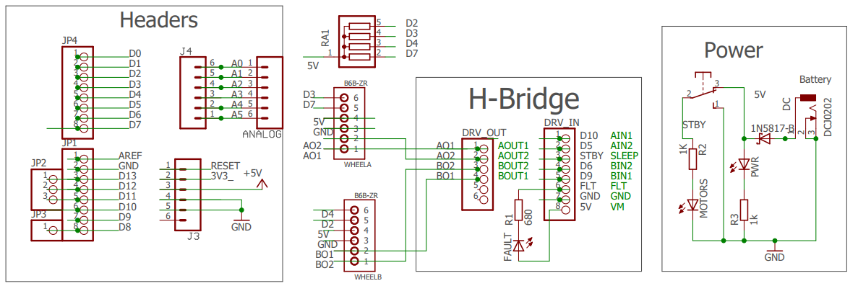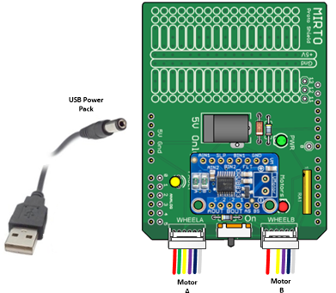

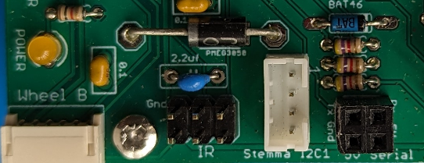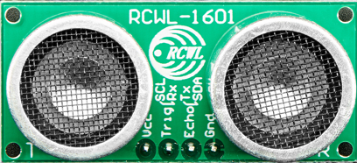

Gnd

+3v  
SDA

SCL

**RCWL -1601 distance sensor wiring**

**Appendix C - Motor Details**

The specifications for the motors measured at 6 volts are as follows:

NO LOAD:

Current: < 0.15 Amps Max

Speed: 197±10%rpm

ON LOAD :

Torque: 0.7kg.cm

Current: < 0.54A Max

Speed: 158±10%rpm

STALL:

Current: < 2.87 Amps

Torque 4kg.cm

Gearbox Ratio 1:34

Maximum Motor Drive Voltage: 8.4 Volts

